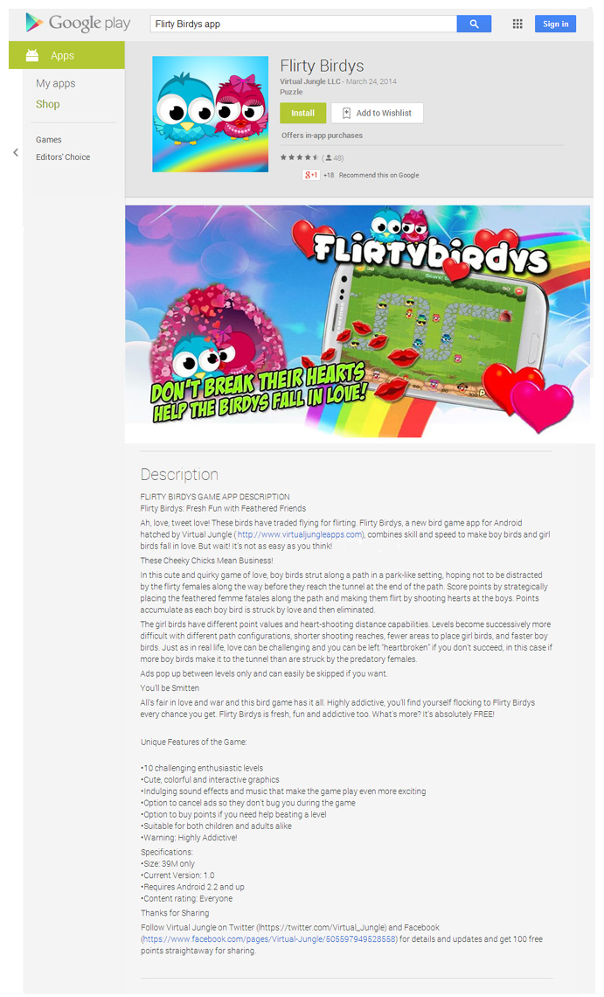
Flirty Birdys: Fresh Fun with Feathered Friends

Ah, love, tweet love! These birds have traded flying for flirting. Flirty Birdys, a new bird game app for Android hatched by Virtual Jungle, combines skill and speed to make boy birds and girl birds fall in love. It’s not as easy as you think!

These Cheeky Chicks Mean Business!

In this cute and quirky game of love, boy birds strut along a path in a park-like setting, hoping not to be distracted by the flirty females along the way before they reach the tunnel at the end of the path. Score points by strategically placing the feathered femme fatales along the path and making them flirt by shooting hearts at the boys. Points accumulate as each boy bird is struck by love and then eliminated.

The girl birds have different point values and heart-shooting distance capabilities. Levels become successively more difficult with different path configurations, shorter shooting reaches, fewer areas to place girl birds, and faster boy birds. Just as in real life, love can be challenging and you can be left “heartbroken” if you don’t
succeed ─ in this case, if more boy birds make it to the tunnel than are struck
by the predatory females.

Ads pop up between levels only and can easily be skipped if you want.

You’ll be Smitten

All’s fair in love and war and this bird game has it all. Highly addictive, you’ll
find yourself flocking to Flirty Birdys every chance you get. Flirty Birdys is
fresh, fun and FREE!

Thanks for Sharing

Follow Virtual Jungle on Twitter and Facebook for details and updates and
get 100 free points for sharing.

Features:

- 10 challenging levels
- Cute, colorful graphics
- Sound effects and music
- Option to cancel ads
- Option to buy points
- Size: 39M
- Current Version: 1.0
- Requires Android 2.2 and up
- Content rating: Everyone

