{NOTE: Replace main photo and animate “Bandy” raccoon character}

[top banner headline]

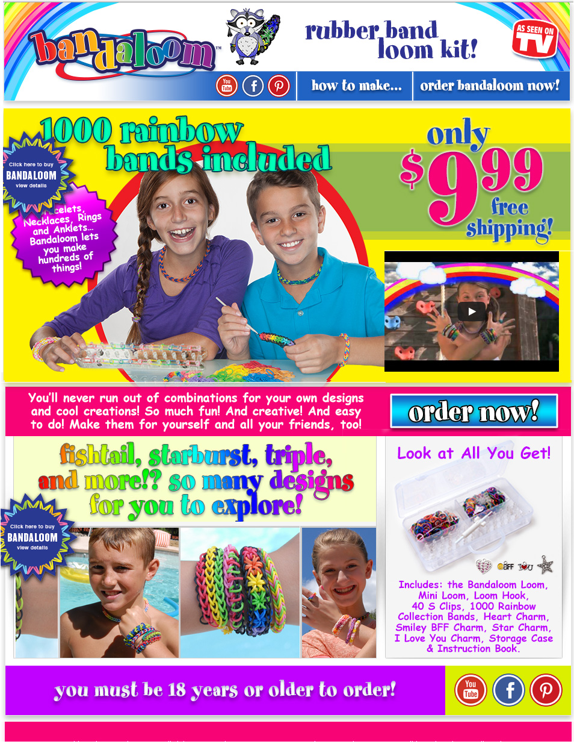

New Main Photo

Home Page

the rubber band loom kit that’s easy to use

[logo]

[headline]

More Colors! More Bands!

More Fun!

[copy]

Necklaces, anklets,

headbands and rings…

Bandaloom lets you make

hundreds of things!

[copy]

Bracelets and belts

and so much more,

in lots of colors

you’ll adore!

[copy]

You’ll never run out of combinations

for your own designs and cool creations!

Fishtail, starburst, triple, and more!

So many designs for you to explore!

[copy]

Fun, creative, and easy to do!

Make them for yourself and all your friends, too!

GRAPHIC:

[Offer headline]

Bandaloom Kit

[Offer copy]

with 1000 rubber bands, storage case, mini loom, and charms

only $9.99

plus free shipping!

[hyperlink copy]

order now!

[photo caption copy]

[photo: product shot with all components]

Look at All You Get!

[photo caption copy]

[photo: 2 or 3 upsell items]

Get even more Colors and Charms

and Stuff!

[disclaimer copy]

you must be 18 years or older to order