One-Of-A-Kind
Something Special is a member-run boutique offering unique, handcrafted gifts. These original works of art have been created by people from all walks of life who are affected by aphasia. Trained in the craft by the Adler Aphasia Center, these talented artisans create one-of-a-kind pieces using the finest materials, including genuine silver, crystals, precious mineral stones, and art glass. All sale proceeds support the Adler Aphasia Center in conducting research, training healthcare professionals, assisting caregivers, and offering post-rehabilitative programs to its members.
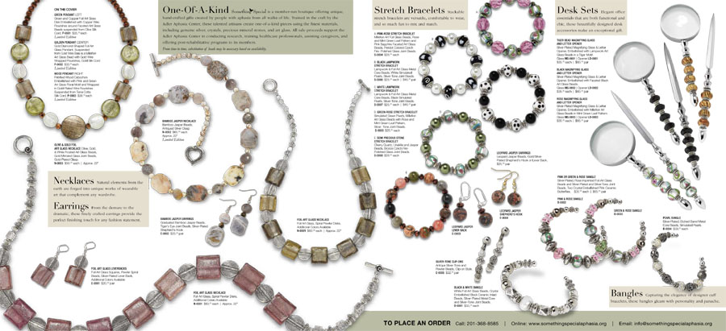
Stretch Bracelets
Stackable stretch bracelets are versatile, comfortable to wear, and so much fun to mix and match.

Desk Sets
Elegant office essentials that are both functional and chic, these beautifully designed desk accessories make exceptional gifts.

Necklaces
Natural elements from the earth are forged into unique works of wearable
art that complement any wardrobe.

Earrings
From the demure to the dramatic, these finely crafted earrings provide the
perfect finishing touch for any fashion statement.

Bangles
Capturing the elegance of designer cuff bracelets, these bangles gleam with personality and panache.

