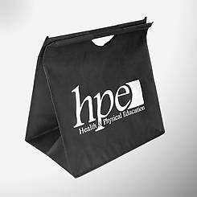
Deluxe Rod Handle Shopping Bag
Give this versatile tote away and watch it carry your brand message around all day! This lightweight, large capacity bag features an extra-wide gusset – making it perfect for books, papers, electronic gear, and grocery items. Rod handles and an easy hook and loop closure make it both fashionable and functional. Non-woven polypropylene containing 40% recycled content.
Item size: 15’’w x 17’’h x 10’’d.
Screen imprint area: 6” w x 4” h, front and/or back

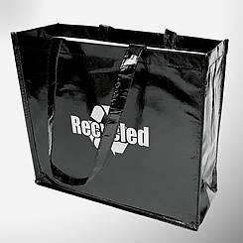
Laminated PET Shopping Tote

This sleek, laminated bag has extra shine appeal – the better to show off your company name, brand name, or logo. This extremely versatile tote features comfortable 24” long handles and bound seams for enhanced durability. The laminated finish is easy to wipe clean. Made of laminated ECOTEXX with 85% post-consumer recycled (PET) content, it’s eco-friendly as well as chic!
Item size: 15 1/2’’w x 14’’h x 6’’d.
Screen imprint area: 6” w x 4” h, front and/or back

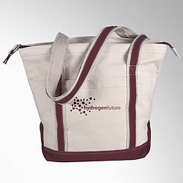
Classic Boat Tote

This classic, durable canvas tote is something your customers will appreciate for years to come. It’s the perfect carry-all for shopping and day trips. Great features make it an extraordinary value: double-layered reinforced bottom and wrap-around handles, inside zippered pocket for keys, change, and receipts, roomy front center pocket, and two side pockets. Biodegradable, premium 16 oz. cotton canvas.
Item size: 20’’w x 15’’h x 9’’d.
Screen imprint area: 5” w x 3” h, front and/or back

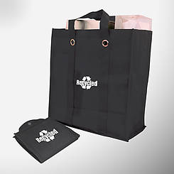
Foldable Shopping Tote

Distinguish yourself from the competition with this unique tote that your customers will love to use! It folds to fit into a glove compartment, briefcase, or handbag. Its 20’’ wrap-around handles and 6’’ gusset make it an ideal grocery shopping bag. Bound seams add strength and durability; and a bottom insert provides stability. Non-woven polypropylene containing 40% recycled content.
Item size: 12 ½” w x 13 ½” h x 6’’d (open), 6 ¼ “ x 6 ¼” (closed).
Screen imprint area: 5” w x 3” h, front and/or back

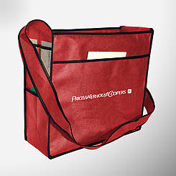
Trade Show Tote

Stand out from the crowd and increase traffic with this hardworking tote – great for getting your name around trade shows and conferences. It features a wide 6” bottom gusset, deep front pocket, plus a utility pocket and two clear plastic business card pockets on each side gusset. The adjustable shoulder strap frees users’ hands and gives them a comfortable wear all day. This bag is great for general office or school use and is always in demand. Non-woven Polypropylene with 40% recycled content.
Item size: 16’’ w x 14’’h x 6’’d.
Screen imprint area: 6” w x 4” h, front and/or back

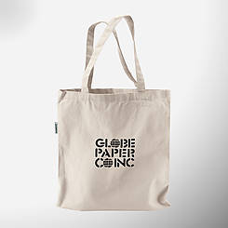
Reusable Cotton Tote

This roomy, environmentally friendly tote is lightweight yet durable – perfect for carrying magazines, books, and paperwork. Your customers will find this all-purpose tote truly useful and will take it – and your company name – everywhere. Features 20” long handles. Biodegradable 10 oz. recycled cotton canvas.
Item size: 15’’w x 16’’h.
Screen imprint area: 6” w x 4” h, front and/or back

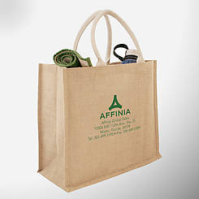
Large Jute Shopping Bag
Give prospective customers an easy way to remember your brand with a gift they’ll use every day. This eco-friendly jute tote sends the right “green” message for your company or brand. Its spacious interior is laminated for enhanced durability. Also features comfort-grip cotton handles. A strong, versatile, large capacity tote for everyday use. Natural and biodegradable jute material. Item size: 16’’w x 14’’h x 6’’d.
Screen imprint area: 6” w x 4” h, front and/or back

