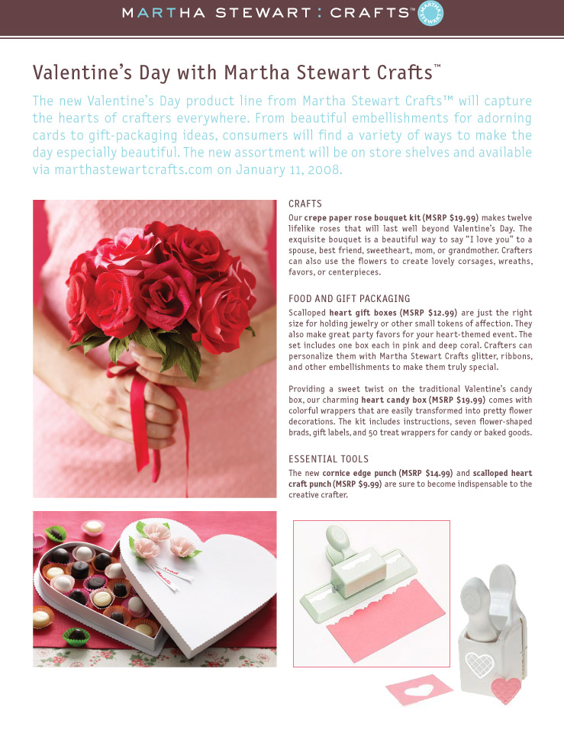
Valentine’s Day with Martha Stewart Crafts™

The new Valentine’s Day product line from Martha
Stewart Crafts™ will capture the hearts of crafters everywhere. From beautiful embellishments for
adorning cards and gifts, to the sweetest gift packaging ideas, consumers are sure to find everything their hearts desire. The new assortment will be on store shelves and available via marthastewartcrafts.com on (date).

CRAFTS

Lovingly craft this exquisite crepe paper rose bouquet (MSRP: $19.99) and watch romance bloom. These lifelike roses will bring joy to the object of your affection long after Valentine’s Day has passed. It’s a beautiful way to say “I love you” to a spouse, best friend, sweetheart, daughter, mom, or grandmother.

FOOD AND GIFT PACKAGING

Scalloped heart gift boxes (MSRP: $12.99) are just the right size for holding jewelry or other small tokens of affection. They also make great party favors for your heart-themed event. The set includes one box each in pink and deep coral. Crafters can personalize them with Martha Stewart Crafts glitter, ribbons, and other embellishments to make them truly special.

Providing a sweet twist on the traditional heart-shaped candy box, our charming heart candy box (MSRP: $19.99) comes with colorful wrappers that are easily transformed into pretty flower decorations. The kit includes instructions, 7 flower-shaped brads, gift labels, and plenty of candy wrappers to hold sweet treats.

ESSENTIAL TOOLS

The new cornice edge punch (MSRP: $14.99) and scalloped heart punch (MSRP:
$14.99) are sure to become staples of the creative crafter’s collection.

