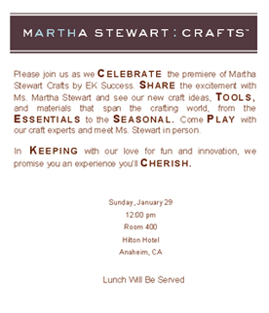
Assignment:
Invitation for a press and key account luncheon at the Crafts and Hobby Association trade show announcing the launch of Martha Stewart Crafts.
The copy incorporates the names of the eight product categories being introduced under the Martha Stewart Crafts brand: Celebrate, Share, Tools, Essentials, Seasonal, Play, Keeping, and Cherish.

Please join us as we Celebrate the premiere of Martha Stewart Crafts by EK Success. Share the excitement with Ms. Martha Stewart and see our new craft ideas, Tools, and materials that span the crafting world, from the Essentials to the Seasonal. Come Play with our craft experts and meet Ms. Stewart in person.

In Keeping with our love for fun and innovation, we promise you an experience you’ll Cherish.

Sunday, January 29
12:00 pm
Room 400
Hilton Hotel
Anaheim, CA

Lunch Will Be Served

