Nuance™ App for iPad® and Android™ OS

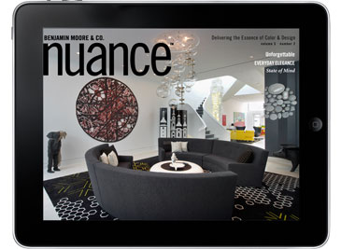
Experience the new, interactive issue of Nuance™ magazine—now available on your iPad or Android OS device

Why just flip through the pages of a magazine when you can get everything you want right at your fingertips? Nuance, created by Benjamin Moore with architects and interior designers in mind, is now available as a convenient, richly interactive app, with more articles and information on color, design, and product, including online chip ordering and videos that bring features to life.

- Scroll through both text and images, and take control of the information with
just a touch

- Watch video interviews of designers featured in current and recent issues of Nuance

- Order paint chips online

- Quickly access our Architect & Designer Representative locator

- Use our Pocket Product Guide to lead you to the perfect product for your project

- Find out more about the paints and paint colors featured in the articles, including paint dollops and room shots using the colors discussed in the articles

- Link to sites where our products can be purchased

Download the application for your iPad

Download the application for your Android OS

